FUNDRAISING PACK

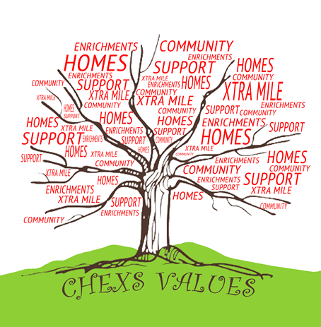
Inside this Pack...

First things first, a big thank you for choosing to fundraise for CHEXS.

With your help we can continue to be there for thousands of children in

Schools burdened by their troubles. We help enable them to view their life with a sense of hope, rather than hopelessness.
CHEXS also works to with the children’s families and teachers.

This fundraising pack will provide you with everything you need to get started, including a range of inspiring event ideas, handy tips for raising sponsorship, and all the practical pointers necessary to ensure your fundraising goes smoothly.

Thank you again and hope you also have lots of fun during the journey!

- The A to Z of Fundraising

- Planning your Event

- Raising Sponsorship

- Creating your Virgin Money Giving Page

- Fundraising Guidelines

- Useful Websites

- Case Study Story / Typical School Day

- Money Return Form

- Case Study Story

- Sponsorship Form

- Finally...

Peter Maiden

Chief Executive
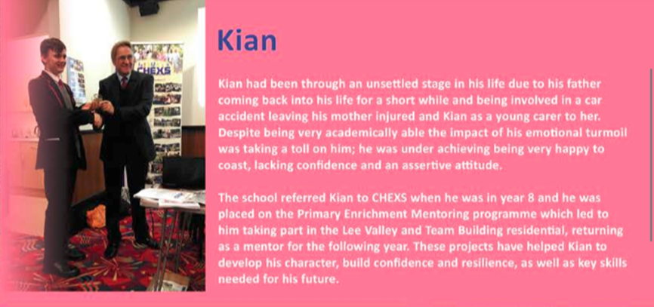

The A to Z of Fundraising

Here are some fun and inspiring ways to get involved in fund-raising activities so you can help us make a real difference to children & Young people

A Place at the Table—see page 5 Auction

Bag Packing

Bingo Night

Book sale

Bake Off—see page 5

Car Wash

Come Dine with Me

Coffee Morning

Carol singing

Donate a Day’s Wage

Dress-down Day

Dog walking

Easter Egg Hunt

Eighties Night

Eurovision Night

Fashion Show

Face Painting

Film Night

Football Competitions

Jumble Sale

Karaoke

Left Handed Day

Lunch Swap

Monopoly Marathon

Murder Mystery

Masked Ball

No Alcohol Challenge!

Nearly New Sale—Invite people to bring unwanted clothes, accessories, books and other knickknacks. Ask for either an entrance fee or by asking every-one who takes something home to make a donation.

Open-Mic Night

Office Swear Jar

Olympic Games

Games Night

Golf Tournament

Guess the … (e.g. number of sweets in the Jar, weight of the teddy etc)

Hair Shaving/ Waxing

Halloween Party

Halloween Collection—Trick or Treat!

International Food Evening

Ironing Service

The A to Z of Fundraising

Piggy Bank

Pancake Day

Quiz Night

Raffle

Record Breaking

Attempt to set a new world record, check out www.guinnessworldrecords.com for ideas, instructions and regulations.

Sports Day

Sweep Stakes (e.g. Grand National)

Sushi Making Night

Sponsored Silence

Speed Dating

Treasure Hunt

Tombola

Talent Contest

Unwanted Presents Swap/ Sale

Valentine’s Delivery Service

Wine and Cheese Evening

Xmas Jumper Day

Yuletide Greetings

Instead of sending seasonal cards during holiday time send e-cards and donate the saved cost of your cards to CHEXS. Even better, we have a selection of cards with children’s artwork which you can buy.

Zoo Themed Night

If you are doing your own event then please do get in touch for further suggestions, help and support or any other information. We are more than happy to help you out in any way we can!

Telephone: 07970 498966
Email: admin@chexs.co.uk

Why Children need CHEXS

Joe is diagnosed with ADHD and was about to undergo assessments to ascertain whether he had high functioning autism. He suffers with ticks and colour blindness and has very low self-esteem. His emotions were unpredictable and he struggled with how others perceived him. He was referred to CHEXS as in class he struggled to focus, would fiddle constantly and need reminders of the task. He also struggled with friendship groups and has been subject to bullying leaving him very emotionally low and frustrated. He was at risk of exclusion as he is becoming increasingly physically violent. Joe’s younger brother, Jordan was starting to copy Joe’s behaviour becoming argumentative with his family. Joe took part in the Primary School intervention projects over an academic year whilst his family accessed parental support both one to one and group and CHEXS family craft sessions with CHEXS authoring a family assessment ensuring additional services and support was in place.
As a result of these interventions the sibling’s relationship has improved, Joe is more engaged and progressing at school and is a lot happier in himself wanting to be more successful at school. He feels he ‘has learnt how to work better in a group’ and feels more relaxed and able to deal with difficult situations. His mother stated that the group means ‘he can have successful fun activities to improve his self-esteem and know he is accepted’. At school his class teacher stated that Joe had learnt to work with others; had really enjoyed the sessions and had raised self-esteem and felt valued.

Food4Thought

CHEXS is asking everyone to invite friends round to enjoy food, drink and conversation in support of its work. Hold a

lunch, BBQ, picnic, coffee morning or host a delicious dinner and raise money for CHEXS.

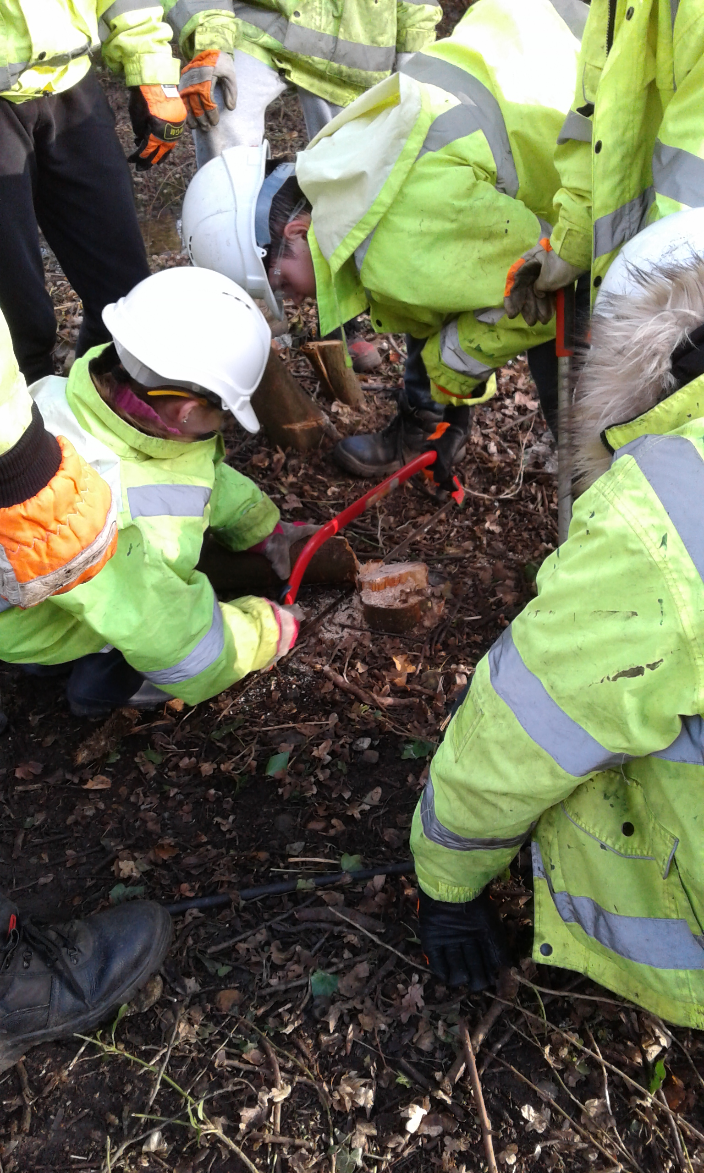
Bake Off

- Have an office bake sale

- Get competitive with an interdepartmental bake off

- Invite friends over for tea and cake

- Sell cakes to your neighbours

Get involved because for many children life isn’t always a piece of cake!

Friends at the Table

It’s simple – have a dinner, raise money, make a difference!

Invite your friends and family over for a dinner party as paying guests. A great way of fundraising whilst socialising and treating yourself to some delicious food.
Planning Your Event

We’ve put together some pointers to help you keep things running smoothly along the way!

What do you fancy?

There are so many exciting fundraisers you could hold for us that it can be difficult know which to choose! A good starter is to think of who you’ll invite and what they’d enjoy. See our A-Z of Fundraising for some Inspiration.

It’s fundraising o’clock!

Think about weather and timing:

- Inviting students? Steer clear of morning events!

- Thursdays or Fridays are great for a work event – everyone is gearing up for the weekend.

- Keep weather conditions in mind for outdoor events.

- Check to see if there are any similar events happening nearby at the same time as yours.

Location, location, location!

- Make use of places you can get for free or at a reduced charity price or bargain the price down - a community centre, church hall, or campus coffee shop are good places to start.

- Decorate the room and put up some CHEXS balloons – add fairy lights and comfy cushions and even your living room can be transformed into the perfect venue!

Pennies make pounds

- Have a clear budget and achievable target in the planning stages.

- Consider how to cut costs, e.g. publicise your event through Facebook and Twitter rather than posters.

- Good-will – ask favours from people—musical contacts to provide entertainment - and donated goods for raffle prizes/ food and drink for refreshments. Just make sure to give plenty of notice and ask us for a letter of authorisation to show that your event is for charity.

With a little help from your friends

- Ask friends for a helping hand with setting up, co-ordinating donations, serving food and drink and providing entertainment.

- Make it a group effort and you’ll have loads of fun!

Spreading the word

- If your event is open to the public or your endeavour is unusual or exciting we can help you contact local press and media to generate interest. We cannot guarantee coverage but do get in touch if you would like to give this a go.

- Use social networking sites to invite people and ask for help.

- Invite five friends and ask them to invite five more.

- Posters in the community hall, local shop windows, or your work/college notice board.

Maximising donations

- Ask your employers to match the funds you raise.

- A raffle can be included in any event and is a great way to convince people to donate as they have a chance of winning a prize.

- Introduce a competitive element to your event – this will give the fundraising a buzz.

Quote Yr 2 child  HAPPY, SAFE, KIND, HELPFUL because I like being with CHEXS, because you help children to be good and be safe | 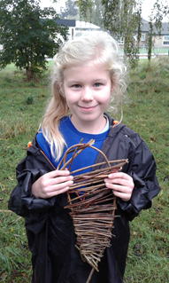

Raising Sponsorship

Here are some top tips on raising sponsorship money.

Personalise the enclosed sponsorship form (e-mail us if you need additional copies) with details of your sponsored event or activity.

Set up an online fundraising page on Virgin Money Giving – you can include a message from you, photographs, videos and details about CHEXS. Online fundraising pages work best when you add a personal feel and make people smile! Update your page as you prepare for the event. The unique link to your page will provide you with a quick and easy way to remind people to sponsor you.

What makes your sponsored event stand out? Give it a tagline and add the personal touch. A sponsored silence if you warble in the shower will be a welcome break for your family, or an organised run is an impressive challenge if you only ever run for the bus!

Get somebody generous to sponsor you first

– others will hopefully follow their lead!

Ask your friends or family to tell their friends about your sponsored event – they could take a copy of your sponsorship form into their workplace.

Invite people to come along to your challenge, or promise video/photographic evidence once you have completed the event.

If people are going to sponsor you they will want to know their money is going to a good cause. We have plenty of case studies and leaflets with information about CHEXS which you can pass on to your friends.

Contact the Fundraising team for stickers and other materials. Make use of balloons and a CHEXS t-shirt on the day to draw attention to what you’re doing. Where possible take a collection bucket/sponsorship form for any last minute donations or pledges.

Use social networking sites such as Facebook and Twitter to update people on your training

and fundraising and remind them to sponsor you.

Ask everyone you know! Don’t be shy! Do your friends, family or colleagues have useful contacts? Think beyond asking the people closest to you – ask those in your social circles too, such as yoga class, sports club, or the café you frequent. Approach companies for raffle prizes to add an extra element to your fundraising. Many companies have Company Giving schemes, so ask your employer to match the donations you raise.

If your sponsored activity would make a good talking point we can help you contact local press and media. While we cannot always guarantee coverage we are happy for you to get in touch if you would like to give this a try.

Send sponsorship reminders at key points in the run-up to and after your event:

- Each time you have an update, such as news on how your training is going, photographs, once you’ve reached the half way mark in your fundraising ‘nearly there…etc’

- Ask just after pay day – people will be feeling more generous!

- ‘Two months to go’ email

- E-mail with a case study

- ‘One month to go’ email

- ‘One week to go’ – include information on CHEXS events to friends to come along on the day as well as an ask for sponsorship.

- ‘The event is tomorrow!!!’ email

- Post-event e-mail with an update and last minute reminder to anyone who has not sponsored you yet

Thank people who sponsor you at the time and thank them again once your event is complete. Send them a photograph and a note about how it all went - we’d love to see your photographs and hear your stories too! Let them know they can contact the Fundraising team anytime if they would like more information on CHEXS

Fundraising Guidelines

CHEXS logo and registered charity number

Please feature CHEXS’s registered charity number 1153769 on any materials which you send out about the charity, or when applying for collection permits and licenses (where requested).

If you would like to use our logo on your website, event materials or for any other purpose please get in touch with us directly. We can provide you with the best version for your needs and our handy branding guidelines to point you in the right direction for how to use the logo.

Raffles

If you are organising a raffle please remember that:

- Small raffles held as a part of a larger event are fine as long as ticket sales and the announcing of results take place during the event and there are no cash prizes.

- Tickets may NOT be sold by under 16's

- You need to apply to your local authority or council for a license for any public lottery or raffle.

- If it is a private event, for example if the tickets are sold to members of a private club or your work colleagues, then a license is not required.

- CHEXS cannot claim gift aid on the sale of raffle tickets.

Licenses and permissions

There are a number of activities for which you will need a license. During the planning stages of your event use the list of Useful Websites provided in this pack to carefully check if you will need a license. For example, licenses or permissions will be required for:

• Particular types of lotteries

Visit the Gambling Commission website for more info: www.gamblingcommission.gov.uk

- Collecting funds on the street

- Selling alcohol

- Public entertainment

If your event is deemed by the local authority to be for charity then they should provide the license required free of charge. State that the event is in aid of CHEXS and quote Registered Charity Number 1153769.

Collections

- If you are organising an external collection please contact us to enquire about collecting tins

- Anybody collecting must be over 16 years of age

- When collecting, you must carry your letter of authority and information about CHEXS at all times

- If you are going to be doing a pub crawl or street collection, you must get a license from your local council

- If you are collecting on private property (e.g. a shopping centre) you will only need permission from the proprietor

- Once the money has been collected, it should be paid in within 8 days. You can do a bank transfer or send a cheque. Please do not send cash to

CHEXS.

Health and Safety

When planning any fundraising activity please ensure you consider any health and safety implications and any relevant legislation.

If you are going to sell food and drink, you can contact your local environmental health department for guidelines.

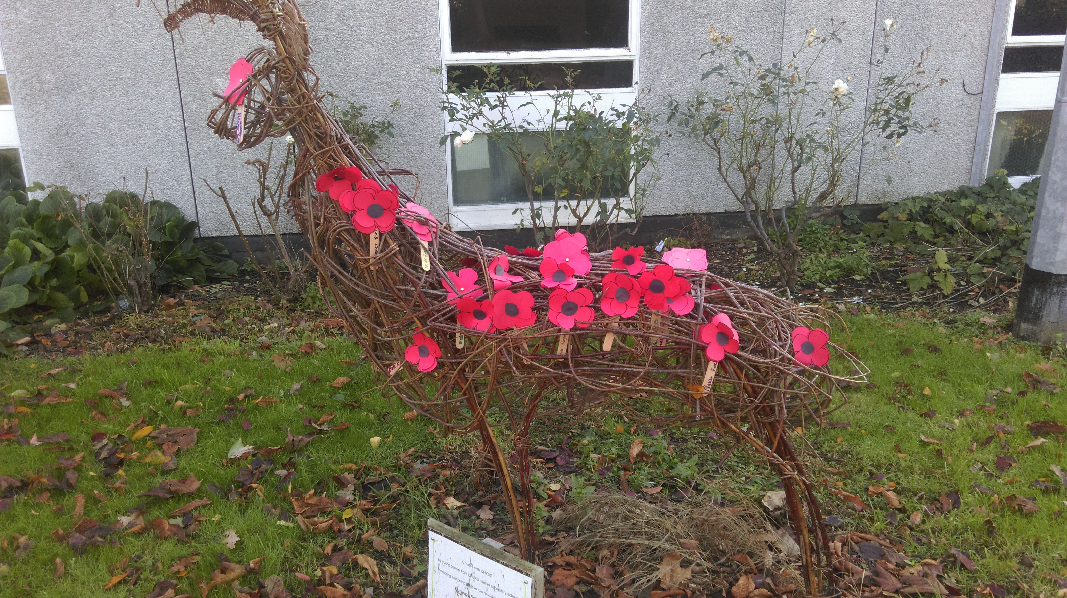
Useful Websites

Fundraising

- Handy fundraising ideas, templates to request pro-bono services for your fundraising event and much more: www.how2fundraise.org

- The Institute of Fundraising: www.institute-of-fundraising.org.uk

- The Directory of Social Change: www.dsc.org.uk

- Charity Commission: www.charitycommission.gov.uk

- For Gift Aid details: www.hmrc.gov.uk

- Student Fundraising Societies (‘Raising and Giving’) Information: www.ukrag.org.uk

- Training advice for challenge events: www.runnersworld.co.uk

Health and Safety

Ensure that your event is organised efficiently and safely. Conduct a risk assessment to ensure that you have proper plans for the safety of participants. For more information visit: www.hse.gov.uk

If you are serving food it must be in a safe and hygienic way, thoroughly cooked and stored at an appropriate temperature. For more information visit: www.food.gov.uk

Raffles and lotteries

Full guidelines on raffles and lotteries are available from your local authority or the Gaming Board and these must be followed in full. For more information please visit: www.gamblingcommission.gov.uk

Year 5 student
‘I learnt to keep trying and not give up’

The week did me good as I would never have started a conversation to make new friends but now I would

Children’s Stories

"I would like to say a big thank you for all your support in the past few months. My son loves to attend all the activities which have been offered by you. He is happy to talk about his feelings and family in front of everyone. Thank you for making my son a more confident person and open to new experiences. I am very pleased about his progress and maturity, which he has got since he started in CHEXS
Parent

Thanks to Chex assembly and sharing he was dyslexic made ##### feel he wanted to share his difficulties with his class so he could prepare himself for Secondary School. I am so relieved and so immensely proud of him too!! His tutor tonight was over the moon.
Parent

Joseph’s Story *

Joseph started volunteering with the charity in September 2014 joining the CHEXS Lee Valley Enrichment Project, a community project where he helped to clear overgrown areas enabling the area to be used by the public.

The school asked if Joseph could join the project as he was having difficulties at home; there was domestic violence, he no longer had contact with his mother and was living in a two rooms within a hostel with his father and two siblings.

This upheaval was making him angry and although he was very keen to do well, he could easily become disheartened and despondent. Once he joined the project he would jump at the chance to attend. He would be there encouraging others to join the team and keeping their spirits high especially when the weather or task became really challenging.

By 2015 Joseph was a regular volunteer becoming the lynch pin of the volunteering group he was part of, making sure everyone knew that they were to attend the project. Joseph coordinated the group to continue volunteering with other projects and became a spokesperson for the group within the charity. Joseph has always been eager to find other avenues where he can support CHEXS, going the extra mile to ensure as many volunteers as possible could join him. Joseph has the ability to put people at ease, will always have a cheerful smile and is excellent at supporting others when the challenges become too hard for them. In recognition of his volunteering and hard work within the community he was awarded runner-up Broxbourne Young Volunteer of the Year Award.

“Seems happier and confident in herself. Her attendance has improved”
School

“Attendance is phenomenal. She has gained a lot of confidence being on the project. Attendance is now 96.2%”
School

Referrers View

Joseph has shown improved behaviour at school and now has a more positive outlook linked to enthusiasm. He rarely has angry outbursts now and has continued with his education into the 6th form.

Joseph’s View

CHEXS has helped me because I've done the things I never imagined I'd complete and learned that when things go wrong I know never to give up
because I've done the hardest challenge! The skills I have learned will help me at home as I am not afraid to do most things now. It has been a life changing experience.

(*False Name)

Jim’s Story *

Jim has faced significant challenges from an early age. For years, he witnessed his Dad abuse his Mum and, since they separated, he’s been a carer for his sister who has learning disabilities.

Jim and his sister were referred to CHEXS, due to their challenging behaviour. Although she has learning disabilities, Jim’s sister was in mainstream education, but struggled with the rigour of school and often lashed out.

First, CHEXS worked with the family to get Jim’s sister a place in a special school, where she is now thriving.

Jim was facing permanent exclusion. His behaviour at school had spiralled out of control. He also started drinking and was regularly in trouble with the police.

Jim now attends our Lea Valley Enrichment Programme, working in the natural environment to improve his self-esteem and confidence through team building exercises. Attending the programme bought near instant success.

Jim’s behaviour improved significantly, he drinks less and we’re pleased to report he hasn’t been in trouble with the police for a long-time.

As his confidence has grown, Jim has developed a passion for forestry. The support he’s received has shown how he can pursue a vocational career working in the environment, and he’s interested in pursuing an apprenticeship.

Jim recently told us, “[CHEXS] taught me lots of things about safety and rules, they didn't just shout at me, they explained things”.

(*False name)
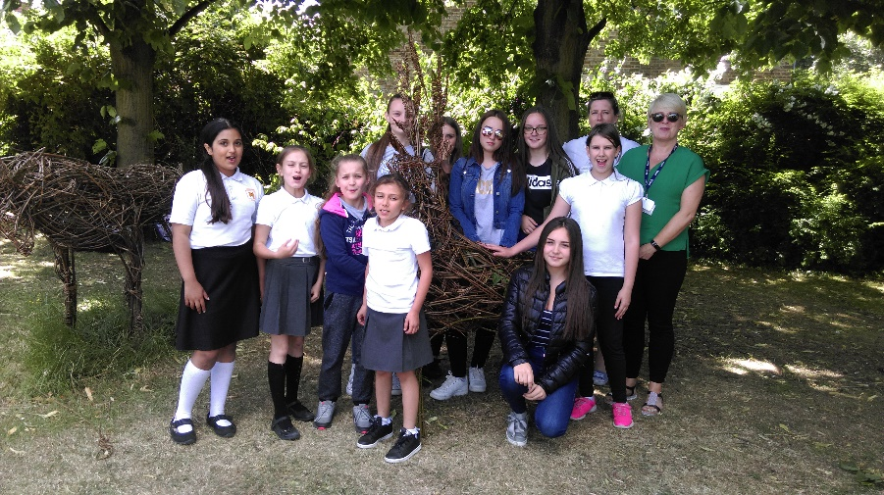

Money Return Form

Thank you for all of your fundraising efforts for CHEXS, we truly appreciate your support.

Please send us a copy of this form each time you send through donations. Cheques should be made payable to ‘CHEXS’ and sent to:

Fundraising Department

CHEXS
CVSBEH Community Skills Hub
59 High Street
Waltham Cross
EN8 7JU

Fundraiser Info:

Money enclosed:

Fundraiser Name

Fundraiser
Address

Event name

Event Date

Cheques | £
enclosed
CAF vouchers | £
enclosed
TOTAL | £

You will be sent a thank you letter as soon as possible to confirm we have received your donation. Thank you for your support!

For Office Use Only

Fundraiser ID:

Event ID:

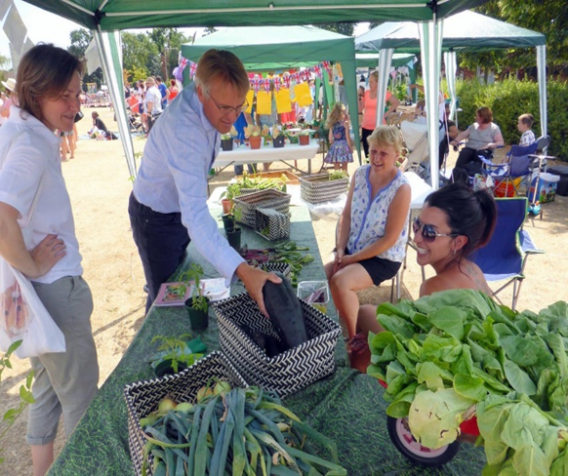

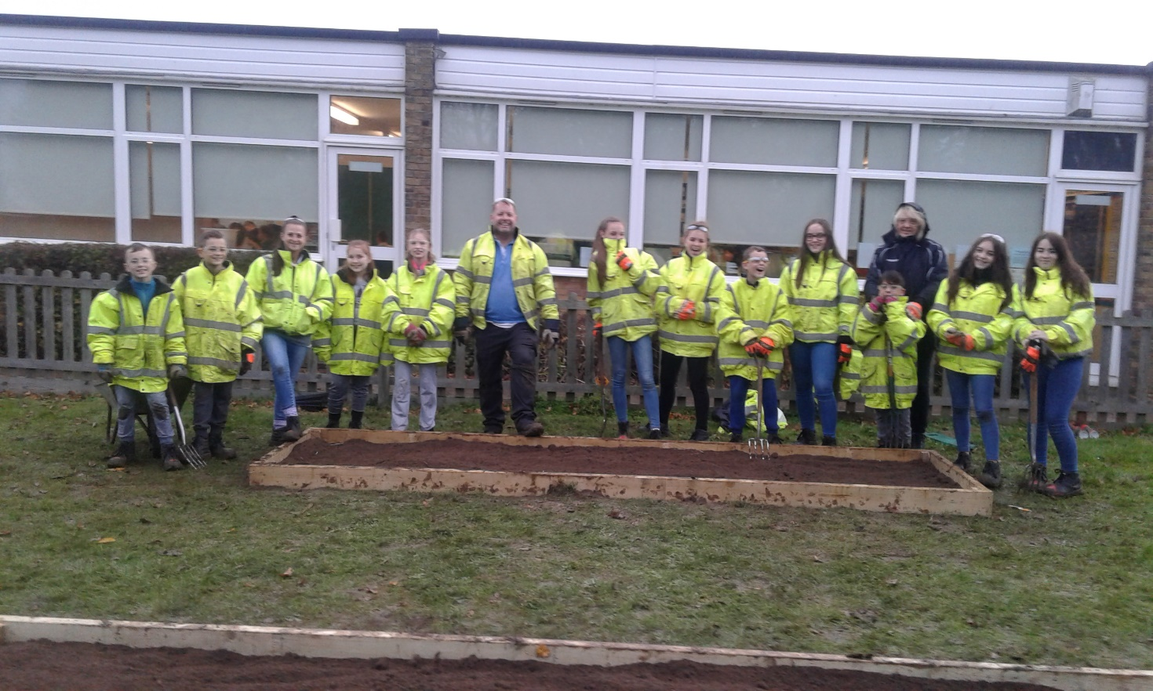

Sponsorship Form

Participant’s email: Participant’s phone number:

All sponsorship raised will go directly towards supporting CHEXS’s work in schools across the UK. Thank you!

GIFT AID INFORMATION FOR DONORS: For every £1 donated CHEXS can claim back 25p as long as you are a UK tax payer and pay an amount of Income Tax and/or Capital Gains Tax equal to the tax that CHEXS reclaims on your donations. To make your donation a Gift Aid donation, fill in your home (not work) address including the postcode and tick the Gift Aid box below.

 |  |  | Home Address | Phone | £Amount | Gift
Title Forename |  | Surname | (must include house number and post |  |  |  | Date | Paid
 |  |  |  | number | pledged | Aid
 |  |  | code for Gift Aid)
e.g. |  |  |  | 020 |  |  | 21/01
 | Joe | Bloggs | 326 City Road, London EC1V 2PT | 8765 | £50 |  |  | yes
Mr |  |  |  |  |  |  | /13
 |  |  |  | 4321

Page no…of … | PAGE | £
Please return completed forms, together with sponsorship money to ‘Events’ at the CHEXS address
 | TOTAL
below (cheques only. Do not send cash in the post).

Sponsorship Form

Participant’s email: Participant’s phone number:

All sponsorship raised will go directly towards supporting CHEXS’s work in schools across the UK. Thank you!

GIFT AID INFORMATION FOR DONORS: For every £1 donated CHEXS can claim back 25p as long as you are a UK tax payer and pay an amount of Income Tax and/or Capital Gains Tax equal to the tax that CHEXS reclaims on your donations. To make your donation a Gift Aid donation, fill in your home (not work) address including the postcode and tick the Gift Aid box below.

 |  |  | Home Address | Phone | £Amount | Gift
Title Forename |  | Surname | (must include house number and post |  |  |  | Date | Paid
 |  |  |  | number | pledged | Aid
 |  |  | code for Gift Aid)
e.g. |  |  |  | 020 |  |  | 21/01
 | Joe | Bloggs | 326 City Road, London EC1V 2PT | 8765 | £50 |  |  | yes
Mr |  |  |  |  |  |  | /13
 |  |  |  | 4321

Page no…of … | PAGE | £
Please return completed forms, together with sponsorship money to ‘Events’ at the CHEXS address
 | TOTAL
below (cheques only. Do not send cash in the post).

Finally...

Once you have completed your fundraising please use the ‘Money Return Form’ to send donations back to CHEXS.

We will acknowledge receipt by email or letter within three days.

If you raised money offline using a sponsorship form please send this to us as well so that we can capture the necessary information to reclaim gift aid on your fundraising.

Contact us any time

CHEXS team is here to help you with your fundraising needs so please do not hesitate to get in touch.

Contact the Fundraising team on 07970 498966 or email admin@chexs.co.uk

