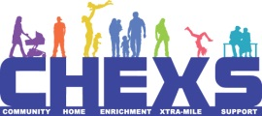

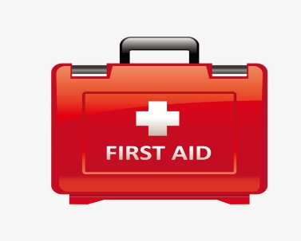
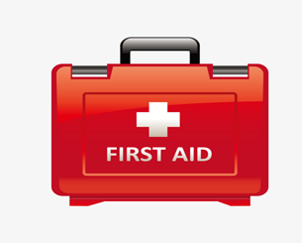
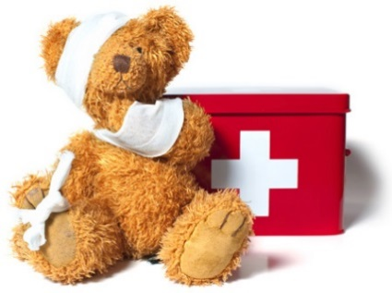

Basic First Aid Course
Basic First Aid session find out what to do in a medical emergency: choking, CPR, bleeeding, what you need in a first aid kit.
COURSE FEE: £29
Dates: Friday 31st January 2020
Time 9am – 12 Noon
Location: Goffs Oak Primary School

If you would like to attend please contact Admin at CHEXS
By emailing admin@chexs.co.uk or calling 07970498966

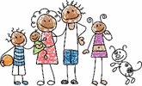
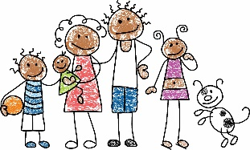
WWW.CHEXS.CO.UK

